# AI ASSISTED CODING

## ASSIGENMET:-09

### TASK:-01

**Task Description#1 Basic Docstring Generation**

* Write python function to return sum of even and odd numbers in the given list.
* Incorporate manual **docstring** in code with Google Style
* Use an AI-assisted tool (e.g., Copilot, Cursor AI) to generate a docstring describing the function.
* Compare the AI-generated docstring with your manually written one.

OUTPUT:-

(12, 9)

TASK:2

**Task Description#2 Automatic Inline Comments**

* Write python program for **sru_student** class with attributes like name, roll no., hostel_status and **fee_update** method and **display_details** method.
* Write comments manually for each line/code block
* Ask an AI tool to add inline comments explaining each line/step.
* Compare the AI-generated comments with your manually written one.

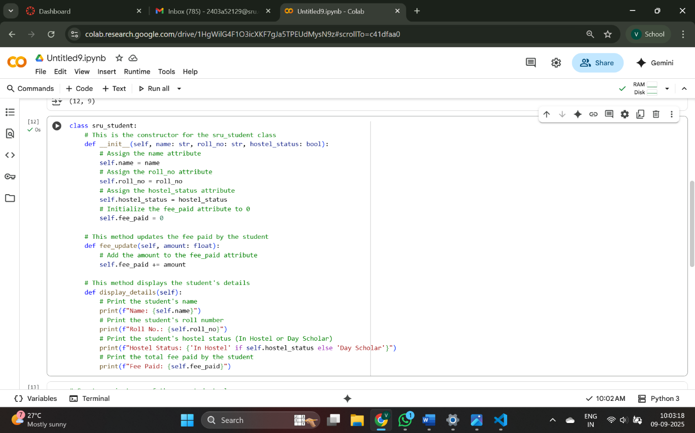

OUTPUT:-

VS CODE:- [Running] python -u "c:\Users\Voma Manikanta\OneDrive\Desktop\html\PP.PY"

Name: Monish

Roll No: 22A91A05B1

Hostel Status: Yes

Fee Paid: Yes

[Done] exited with code=0 in 0.091 seconds

GEMINI:- Name: Alice

Roll No.: SRU123

Hostel Status: In Hostel

Fee Paid: 0

Name: Alice

Roll No.: SRU123

Hostel Status: In Hostel

Fee Paid: 5000.0

### TASK:3

**Task Description#3**

* Write a Python script with 3–4 functions (e.g., calculator: add, subtract, multiply, divide).
* Incorporate manual **docstring** in code with NumPy Style
* Use AI assistance to generate a module-level docstring + individual function docstrings.
* Compare the AI-generated docstring with your manually written one.

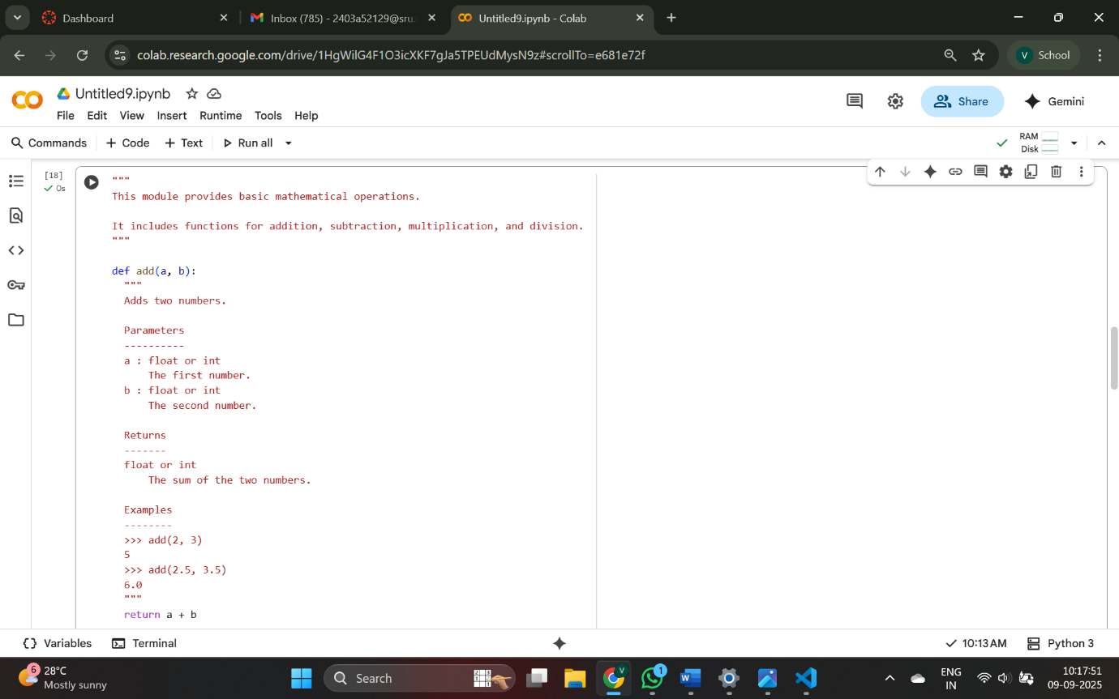

GEMINI OUTPUT:-

6

12

5.0

OUTPUT OF GITHUB:-

[Running] python -u "c:\Users\Voma Manikanta\OneDrive\Desktop\html\JJ.PY"

Add(10, 5): 15

Subtract(10, 5): 5

Multiply(10, 5): 50

Divide(10, 5): 2.0

[Done] exited with code=0 in 0.063 seconds